Response to Watters et al. (2020)

Paper outline

Introduction
In the 70s, penguins believed to be above historic levels given “surplus hypothesis”.
Recovery of whales would affect penguins. Whales are superior competitors for krill.
Adelie and Chinstrap penguin populations in decline. Gentoo populations are growing and expanding in the same region. All are mainly krill predators. Causes not clear.
Krill fishery history. Low catches in 1990s and 2000s. Increased in recent years, but shift to fall-early winter.
CCAMLR approach to fishery management: Article II.
Review literature on fishery impact on seabirds. Main cause is incidental mortality. Competition for food more difficult to test.
Watters et al. (2020) only considered a suite of “breeding performance” indices, but there is no demonstration of the impact of any of these indices on breeding success. Lack of effects on breeding success or survival are key to demonstrate impact from fishing. In addition, data during winter, which is relevant for the significance of the model, is very limited. Use of proxy variables (correlation with ENSO) has not been proved.

Methods
Data description
The time series used by Watters et al. (2020) consisted broadly of (i) penguin parameters, obtained in situ at Cape Shirreff (CAPE), which forage on the Drake Passage area, and Copacabana (COPA), which forage in the Bransfield Strait area. Data for these colonies varied depending on the species and parameters considered but broadly span from 1982-2016 at COPA and 1997-2016 at CAPE. Krill survey data is more limited, with summer surveys spanning from 1996 to 2011, and winter surveys conducted only in 2012, 2014 and 2015. Fishing and environmental (Oceanic Niño Index, ONI; Southern Annular Mode, SAM) data were available for the entire study period. All data was available through the Supplementary Information provided by the authors.
Indices inspection
[pending] We review each penguin performance indicator separately to identify for temporal trends (year), sampling dates, etc., to assess if there are significant patterns that could affect the estimated index values. Several penguin indicators were estimated as representative of summer (fledgling mass, foraging-trip duration, and post-hatch breeding success) and winter (mean clutch-initiation date, mean female and male masses at lay, mean egg density, and relative cohort strength) conditions. Most, if not all, of these indicators are influence by the date on which samples are taken. A such, interannual changes on the date these parameters were taken would affect the measurement of specific indicators.
Krill survey data
Authors used all data available for estimating LKB (local krill biomass), as therefore, LHR (local harvest ratio). However, in their code they noted that some years data coverage was low and suggested filtering years with low acoustic data coverage, eliminating surveys with 80 nm of coverage, although they did not implement it in their results (Supplementary Methods S1, # krill survey biomass). Instead of using a fix cutting level, we analyzed the frequency distribution of acoustic transect surveyed for gSSMU 1 and 2 separately and eliminate surveys on the lower 10th percentile (round up to the nearest 10s).
The authors also imputed summer LKB data for years without survey, to match penguin timeseries. Specifically, they imputed summer LKB values for 1982-1995 and 2012-2016. The imputation process was a two-step process. First, they categorized LKB into two categories: <1Mt and >1Mt. Second, they imputed LKB into either category based simply on the SAM sign (+/-). Further, the authors defined the “best case” scenario when LKB≤1MT; conversely, they included LKB>1MT within the “worst case” scenario. The paper does not provide justification for these assumptions. We tested these assumptions by estimating the median LKB for -/+ SAM years for each gSSMU and revised if <1MT< is an appropriate representation of good/bad conditions for penguin colonies.

Results
Survey Data
Survey coverage varied between and within years. Following the authors own advice, we filtered survey coverage to eliminate surveys with low coverage. We analyzed the frequency distribution of acoustic transects surveyed for gSSMU 1 & 2 and eliminated those samples in the lower 10th percentile (round up to the nearest 10s). The former resulted in the elimination of 4 surveys/leg in gSSMU 1 (transect coverage ≤10; years 1996, 2010 and 2012) and 3 in gSSMU2 (transect coverage ≤200; years 2010, 2011 and 2012) (Figure 1). Thereafter, all analysis used survey data filtered as indicated here.
We also tested whether the correlation used to impute missing LKB was supported by the available data and if the distinction of -SAM<1MT<+SAM was justified (Table 1, Figure 2). Our finding indicates that (i) there are non-significant differences in LKB between -SAM or +SAM, either for gSSMU1 and gSSMU2; (ii) although LKB is lower when SAM is negative, the median value is always greater than 1MT. Thus, imputing values to LKB≤1MT and LKB>1MT based on SAM sign is not only incorrect but has strong effects on estimated LHR.

Table 1. Permutation ANOVA (Approximative Two-Sample Fisher-Pitman Permutation Test)
 | Permutation ANOVA | Median LKB  -SAM | Median LKB  +SAM
gSSMU1 | Z = -1.1643,  p-value = 0.2639 | 1,291,502 t (n=6) | 1,818,980 t (n=10)
gSSMU2 | Z = -1.9038,  p-value = 0.0527 | 3,045,776 t (n=6) | 7,265,616 t (n=10)

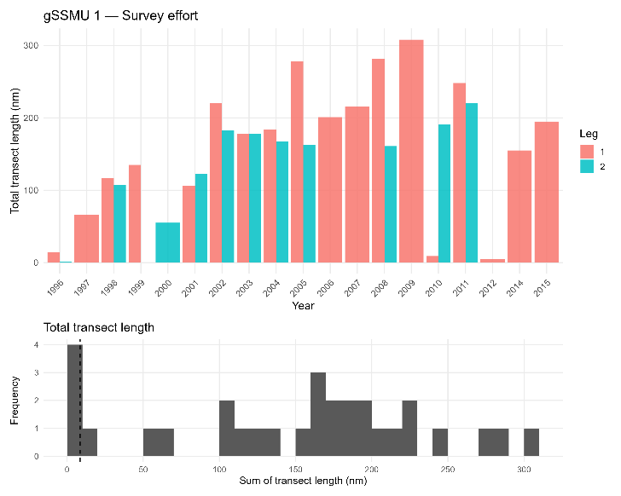 | 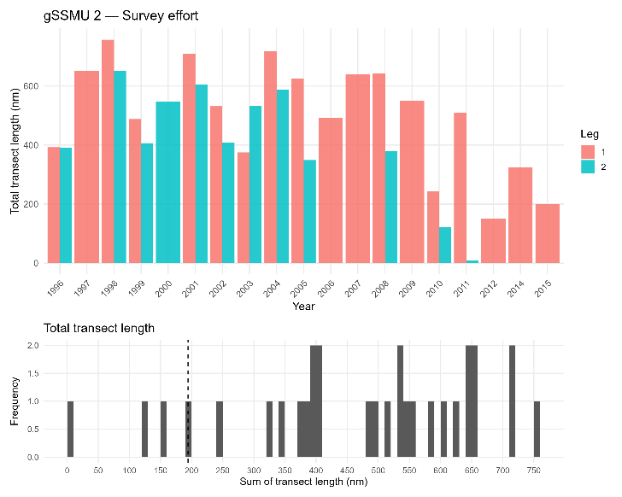
Figure 1. Survey coverage (total transect length surveyed) by gSSMU and year (up). Frequency distribution of total transect length, including the 10th percentile (dashed line) is shown below.

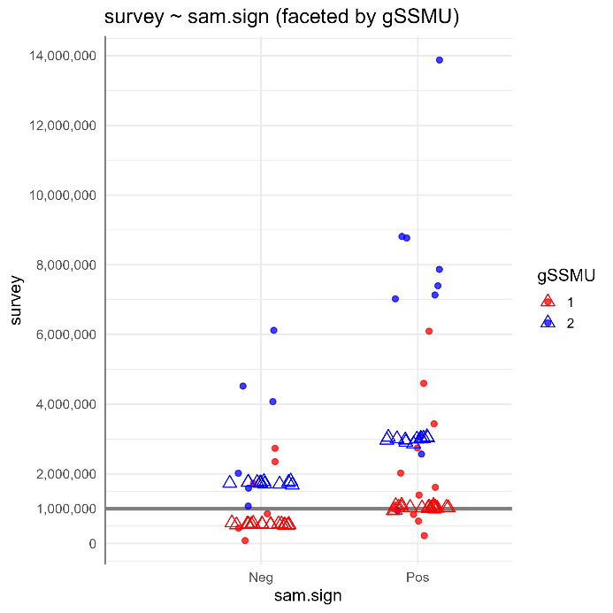 | 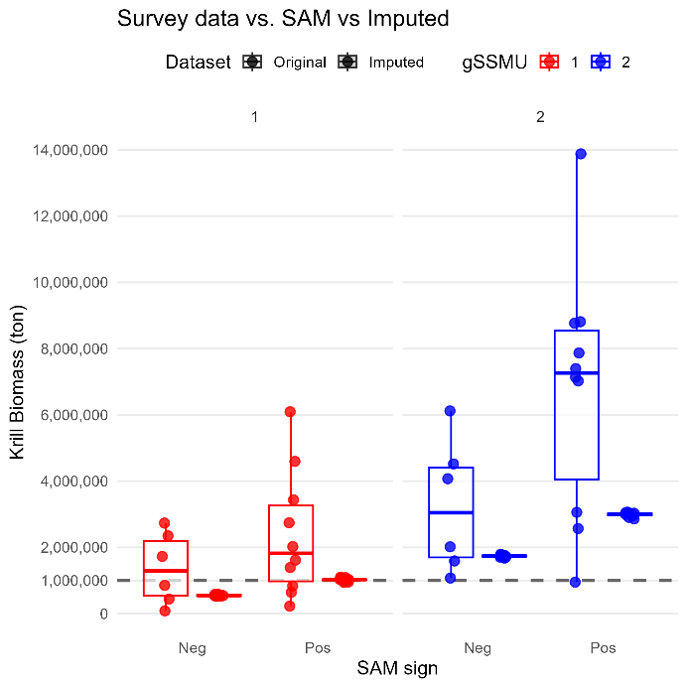
Figure 2. Krill survey biomass estimates during years with -/+ SAM.

Harvest ratio
We re-calculated LKB and LKH after filtering survey data as above. In addition, we imputed LKB for summer using the median LKB for -/+ SAM, as per results shown in Table 1, to compare with results from Watters et al. (2020). Winter data was not imputed.
Harvest ratio during summer were extremely low for the entire period for which survey data is available: ≤1% in the Drake Passage and <2% in the Bransfield Strait (Fig. 3). Using imputed summer LKB, imputed LHR remain low, with a max of 1.9% for the Drake Passage in 1987, and 4.4% for Bransfield Strait in 2013. The former is due to very low catches in the Drake Passage for the study areas and period, only surpassing 50,000 tonnes (peak = 92,878 tonnes) during the summer seasons between 1987 to 1992. Similarly, summer catches in the Bransfield Strait remained extremely low until 2012, only surpassing the 50,000 tonnes in 2014 and 2015 (Fig. 3). By contrast, winter catches in the Bransfield Strait increased since 2009, coincidental with the spread of the trigger level (CCAMLR Conservation Measure 10-09). The former, coupled with a very low krill biomass estimated for 2015, just 176,394 tonnes, resulted on a LHR of 31.6% (Fig. 3). [explain?]
Watters et al. (2020) also noted that harvest rate before 2010 were low. However, it assigned very high harvest rate from 2010 through 2016 [check].
Watters et al. (2020) assigned LHR ≥ 0.10 to the “worst case”, while LHR < 0.01 were assigned to “best case”, and 0.01<LHR<0.10 as intermediate. Based on our results, Bransfield Strait had mainly LHR <0.01, with intermediate LHR occurring only during summer 2010 (0.0165) and winter 2014 (0.012); only winter 2015 was LHR>0.10. When imputed data is added, LHR ranged between 0.028 – 0.044 for summers of 2013, 2014 and 2015. For the Drake Passage, all years with survey data had LHR < 0.01, with intermediate values found for years with imputed data (1987, 1989, 1992) (Fig. 3).

Penguin Indicators

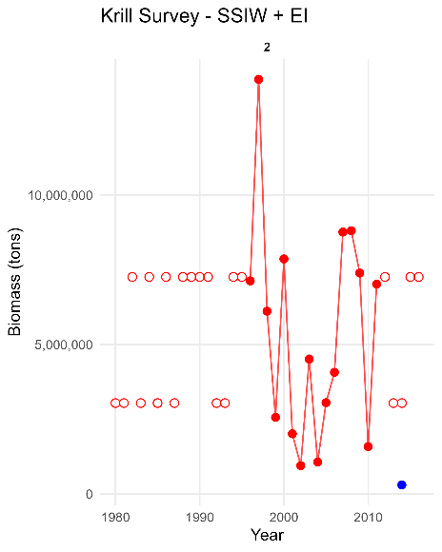 | 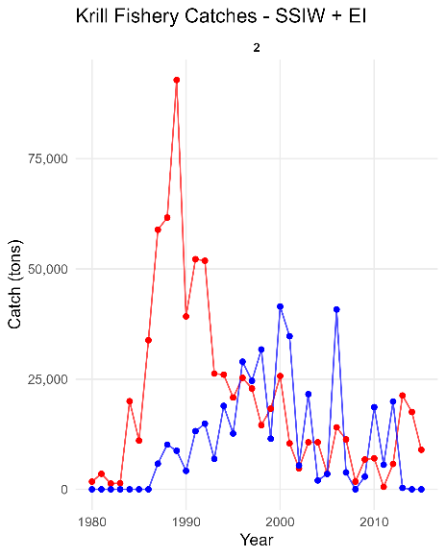 | 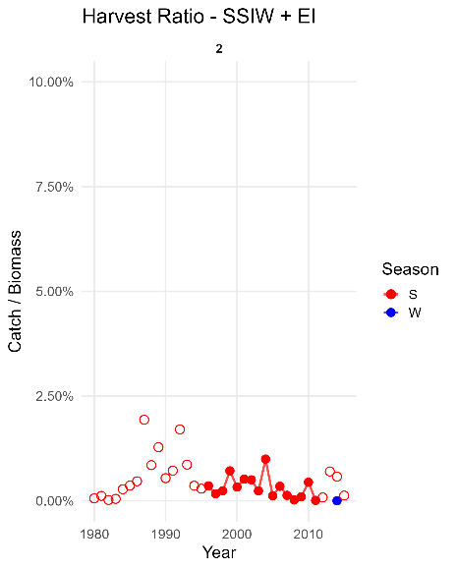
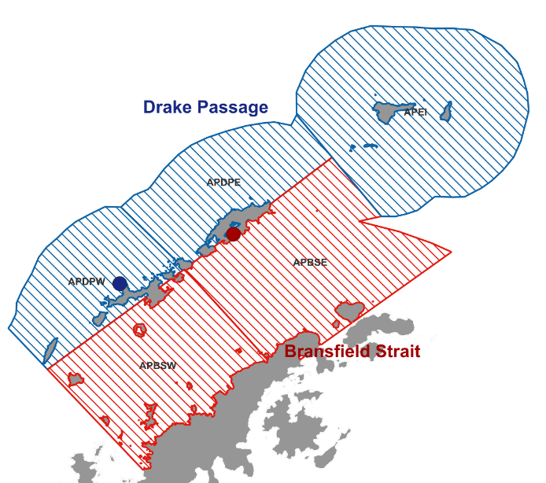
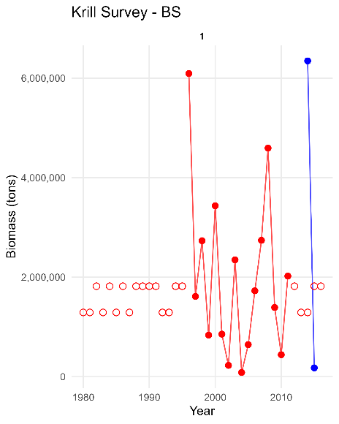 | 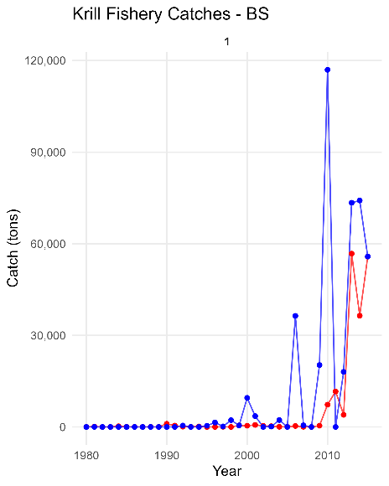 | 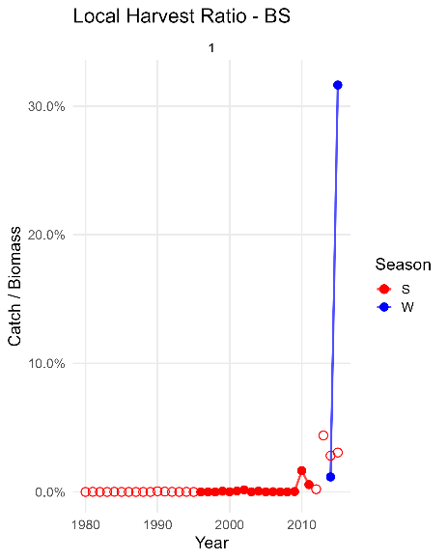
Figure 3. Bransfield Strait area (BS; blue) correspond to gSMMU1 (APBSW and APBSE); Drake Passage area (SSIW + EI; red) correspond to gSMMU2 (APDW, APDPE and APEI).
Discussion
The paper by Watters et al. (2020) is commonly cited to indicate existing impact from krill fishing on penguin performance. However, the paper is based on a series of untested assumptions that, once removed, provide no indication of such an impact.
Krill fishery dynamics
During the period where summer survey data is available (1996-2011), the krill fishery operated mainly during summer months². During this period, krill biomass estimates indicated strong interannual variations, with an oscillation period between 5-6 years (refs). Yet, krill catches were relatively small, below 1-2% of the available biomass (Fig. 3).
As shown in this paper, there were several, accumulative mistakes in the estimation of LKB and LHR, which in turn, increased the imputed effect of fishing on penguin indicators. Krill catches are reported by fishing vessels to CCAMLR and are considered known. LKB were estimated through acoustic surveys conducted by the US-AMLR program between the summers of 1996-2011, plus a limited number of winter surveys. To expand the LKB to match the time series of penguins and krill catches, Watters et al. (2020) made several assumptions regarding the relationship between LKB and SAM, and thus, LHR estimates. We found these assumptions to be incorrect (Table 1; Fig. 2). In addition, we found the imputation of “best case” and “worst case” scenarios based on LKB< 1MT<LKB to be inappropriate, as average LKB varies by gSSMU and had a median greater than 1MT.
As noted by Watters, LHR > 0.10 occurred only during winter and after 2010. After filtering by low survey coverage, only winter 2015 presented a high LHR. Nonetheless, krill catches increased in the Bransfield Strait after 2009, thus we would expect an increase in LHR. If so, we would also expect that breeding performance have a significant difference before and after 2010.[check]
Yet, penguin population trends at each location shown a [describe better] decline throughout the study period, from 1980s (COPA) and late 1990s (CAPE) onwards, with no observed changes after 2010.
[What about the ONI relationship with penguin performance?]

The results from Watters et al. (2020) relays heavily on imputed data. Posterior predictive distributions were local harvest rate LHR≥0.10, either have no data or correspond are supported mainly by winter 9with low survey coverage) and imputed summer data (cases 5,6, 11,12, 17 and18, Supplementary Fig. S7). Moreover, from the 18 simulated cases, the 6 worst performance indices either (i) have no data, (ii) summer LKB was imputed and (iii) are supported mainly by winter LKB data. As indicated above, summer imputed data is flawed, while winter data, after filtering for survey coverage, is almost inexistent (Fig. 3).
The authors noted that when no summer LKB (krill biomass) estimates were imputed, relative importance of local harvest rate (LHR) reversed, with intermediate LHR (0.01<LHR<0.10) having a worst effect than higher LHR (LHR≥0.10), contesting their own results (Supplementary Fig. S8).
We ran the statistic model again under different conditions, and found that the introduction of..

Penguin Indicators
If no imputed data is used, results indicate…...

Penguins as indicators
An assumption of the study is that penguins are good indicators of krill status, yet penguins do not regulate krill abundance. On the contrary, krill seems to have a strong intra-specific competition that controls the large oscillations in biomass observed, which in turn are modulated by changes in primary productivity^{3,4}.
In addition, it is now understood that krill size preference by penguins and the fishery differ, with penguins preferring larger, mature krill, while the fishery catch a broader length spectrum⁵.
Recent analysis suggests that observed effect on seabird breeding performance are result of forage fish accessibility for seabirds rather than just abundance⁶. As such, the analysis should focus on detecting (i) localized prey depletion and (ii) numerical or functional response of seabirds to prey depletion⁷. Then, fishery-seabird competition should be assessed through an integration of observational and experimental (including modeling) approaches⁷. As seen above, the paper failed on both aspects. First, fishing pressure (LHR) for the areas and period study remain extremely low (Fig. 3). Second, there is no cause-effect between indexes used and seabird productivity or survival. As such, the study only presents penguin and fishing correlation to a common driver: krill availability.
The analysis assumes that reduced krill availability would, in part, be an effect of fishing catches in nearby areas. Total biomass estimates for Drake Passage and Bransfield Strait range from 1.16 and 15.50 million tonnes. Penguin population within those gSSMU range from xxx-xxx, with an estimated consumption of xx tonnes of krill annually. According to the above estimates, on years of low krill availability (e.g., 2002, 2004, 2010), penguins (and other predators) would be dying on shores or completely migrate off the region to find food; neither case has been documented.

A key element is that breeding performance studies use breeding success or a proxy variable to analyze effect of prey abundance on the seabird. In the case of Watters et al. (2020), they did not provide a cause-effect between indexes used and breeding performance, a key element to determine impact. As Watters et al. (2020) indicate themselves, population-level consequences other than recruitment are not relevant. Yet, they fail to prove effects on recruitment.
By contrast, penguin population trends at each location shown a [describe better] decline throughout the study period, from 1980s (COPA) and late 1990s (CAPE) onwards, with no observed changes after 2010. Kril catches were the highest between 1979 and 1992, with a significant drop between 1993 and 2009 (CCAMLR). If LHR had a significant effect on penguin populations, it would expected a recover in populations trend after 1992. Yet, that did not happened [].
[Gento penguins are the only species increasing in the Antarctic Peninsula region, as also noted from gentoo trend data at COPA.]

Analysis of fishing impact on wildlife, including seabirds, is commonly conducted through numerical analysis that reflects population dynamics, such as population viability analysis or other. Likewise, CCAMLR manages marine living resources based on long-term projections of population trajectories⁸.(Does Article II also applied to penguins and whales?)
It is well now established that Chinstrap and Adelie penguins are declining in the broader FAO Area 48, including the South Sandwich Islands, South Orkneys, South Shetlands, and the Antarctic Peninsula⁹.
Metanalysis of seabird and fish stock suggests that forage stocks from falling below a threshold of 33% of long-term maximum prey biomass in order to safeguard seabird breeding success, but here we further suggest that a threshold of 18% should be considered as a limit not to be exceeded for the sake of the forage fish themselves ^{6,10}.

References
1. Reiss, C. S., Hinke, J. T. & Watters, G. M. Demographic and maturity patterns of Antarctic krill (Euphausia superba) in an overwintering hotspot. Polar Biol 43, 1233–1245 (2020).
2. Santa Cruz, F., Ernst, B., Arata, J. A. & Parada, C. Spatial and temporal dynamics of the Antarctic krill fishery in fishing hotspots in the Bransfield Strait and South Shetland Islands. Fisheries Research 208, 157–166 (2018).
3. Ryabov, A. B., De Roos, A. M., Meyer, B., Kawaguchi, S. & Blasius, B. Competition-induced starvation drives large-scale population cycles in Antarctic krill. Nat Ecol Evol 1, 0177 (2017).
4. Ryabov, A., Berger, U., Blasius, B. & Meyer, B. Driving forces of Antarctic krill abundance. Sci. Adv. 9, eadh4584 (2023).
5. Panasiuk, A., Gic-Grusza, G. & Korczak-Abshire, M. Availability to predators and a size structure of the Antarctic krill Euphausia superba in the 48.1 CCAMLR subarea. Sci Rep 14, 21538 (2024).
6. Saraux, C. et al. Seabird‐induced natural mortality of forage fish varies with fish abundance: Evidence from five ecosystems. Fish and Fisheries 22, 262–279 (2021).
7. Sydeman, W. J. et al. Best practices for assessing forage fish fisheries-seabird resource competition. Fisheries Research 194, 209–221 (2017).
8. Managing fisheries to conserve the Antarctic marine ecosystem: practical implementation of the Convention on the Conservation of Antarctic Marine Living Resources (CCAMLR). ICES Journal of Marine Science 57, 778–791 (2000).
9. Strycker, N. et al. A global population assessment of the Chinstrap penguin (Pygoscelis antarctica). Sci Rep 10, 19474 (2020).
10. Cury, P. M. et al. Global Seabird Response to Forage Fish Depletion—One-Third for the Birds. Science 334, 1703–1706 (2011).

